**3 RESPIRATION**

**CHAPTER COVERAGE**

**3.1 INTRODUCTION OF RESPIRATION**

**3.2 RESPIRATION OF CARBOHYDRATES**

**3.3 ATP SUMMATION**

**3.4 EFFICIENCY OF ENERGY TRANSFER**

**3.5 RESPIRATION OF ALTERNATIVE RESPIRATORY SUBSTRATES**

**3.6 RESPIRATORY QUOTIENT (RQ)**

**3.7 BASAL METABOLIC RATE (BMR)**

**3.1 INTRODUCTION OF RESPIRATION**

Living organisms always require **energy** to build and repair body structures, and to maintain various activities of life such as movement, reproduction, nutrition, growth, excretion and sensitivity. The energy is stored in carbohydrates, lipids and proteins which comprises the food of many organisms, must, however be converted into forms of ATP which can be used by cells. The process by which energy is made available from food in cells is called **respiration**.

**WHAT IS RESPIRATION?**

**Respiration** is a process by which food substances are oxidized to release energy in the form of ATP, which is needed for metabolic activities in the body, since respiration takes place in living cells; it is also referred to as ″ **cellular respiration”.**

**Breathing versus gaseous exchange**

In some cases; people may confuse between respiration (internal respiration) and breathing (external respiration); The correct concept about these two processes is that: **cellular respiration** is the biochemical process which takes place within the living cells that release energy from food molecules whereas **breathing** is the physiological process involved in obtaining oxygen needed for respiration and the metabolic removal of gaseous waste such as carbondioxide.

**Respiration versus combustion**

People sometimes talk about ″ **burning up food**” in respiration. In fact, likening respiration to combustion is unhelpful; this is due the following main difference:

**Table 3.1 Differences between respiration and combustion**

|  |  |
| --- | --- |
| **Respiration** | **Combustion** |
| It occurs inside the cells | It occurs outside the cells |
| Energy released in steps | Energy released at a time |
| No light is produced | Light is produced |
| Controlled by enzymes | Not controlled by enzymes |
| Intermediate products are present | intermediate products are absent |
| Temperature remains within limit | Temperature rises very high |



**Sample question – 01**

**Tahossa 2022**

Differentiate between the following processes:

1. Whole body respiration and cellular respiration
2. Combustion and cellular respiration

Hints:

Whole body respiration (breathing).

**What are the respiratory substrates?**

**Respiratory substrates** are normally the food substances that are oxidized to release energy in form of ATP in the body. They include the following food substances; Carbohydrates, lipids and proteins.

The difference in energy values of respiratory substrates is due to the amount of hydrogen atoms present in the substrates. The more the number of hydrogen atoms in the molecule of respiratory substrates, the more energy **(ATP)** is generated during respiration, such as l**ipids** energy density is more than twice that of **carbohydrates** because of their long fatty acid tails with large number of hydrogen atoms.

**Table 3.2 Respiratory substrates and their energy values**

|  |  |
| --- | --- |
| **Respiratory substrate** | **Energy value(KJ/g)** |
| Carbohydrates | 15.8 |
| Lipids | 39.4 |
| Proteins | 17.0 |

**a. Carbohydrates**

**Carbohydrates** are the main respiratory substrates used by most respiring cells. In this case; monosaccharaides normally glucose is broken down in respiration is derived from the hydrolysis of starch and glycogen polysaccharides. As with other biochemical processes in the cells, the breakdown of glucose not happen in one jump but in a series of small steps. The pathway can be divided into three (3) parts; glycolysis, Krebs cycle and electron transport chain (This will be depicted in the next section).

**Why glucose (carbohydrate) is used as primary respiratory substrates?**

Carbohydrate principally glucose is used as primary respiratory substrates due to the following reasons:

1. It is most abundant in the body cells, thus is available for respiration.
2. It is hydrolysed easily than any other respiratory substrates.
3. It is small molecule and soluble in water hence simple to transport by the blood to the respiratory tissues.
4. It is respired even in the absence of oxygen gas hence can be respired anaerobically in the case of oxygen insufficiency.



**Sample question – 02**

**Kilimanjaro Mock – 2019**

1. A camel stores fat in hump as a source of water rather than as energy source, by what type of metabolic process would water made available from fat?
2. Explain why carbohydrates have less energy per molecule than lipids, but the body prefers carbohydrates in favour of lipids production?

**Why lipid is not used as primary respiratory substrates?**

Lipid produces large amount of energy in respiration, however it is not used as primary respiratory substrates due to the following reasons:

1. Lipid is the major component of the cell membrane hence retained for that purpose.
2. It is not easily hydrolysed.
3. It is large molecule and insoluble in water hence difficult to transport by blood to the respiratory tissues.
4. It is respired only in the presence of oxygen gas hence cannot be respired anaerobically.



***Did you must know!***

***A camel can survive for 15 days without water due to the consumption of metabolic water produced from the oxidation of fat stored in the hump.***

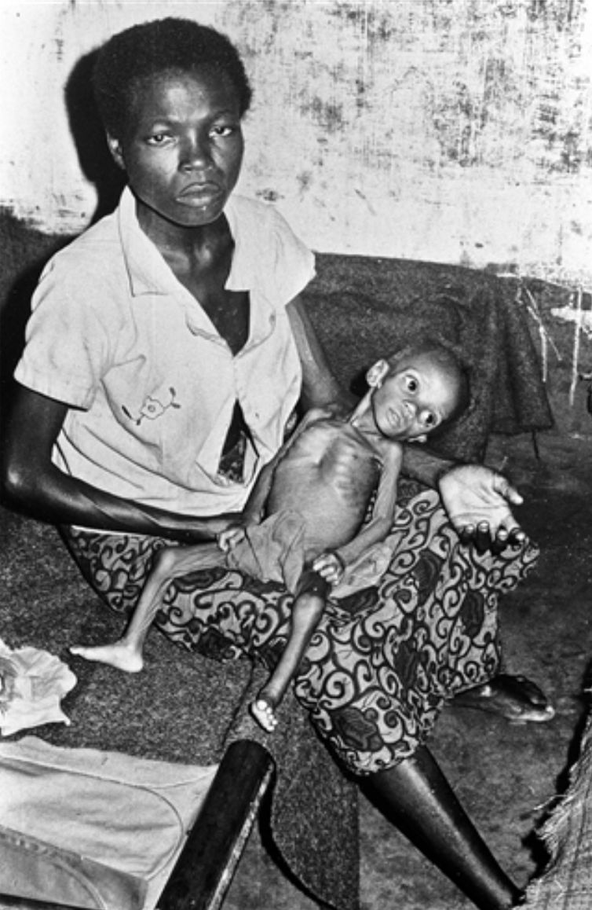

***Fig 3.1:*** *a child with marasmus respire proteins as respiratory substrate.*

**Sample question – 03**

**Kilimanjaro Mock 2020**

1. Lipids produce large amount of energy in respiration however, it is not used as primary respiratory substrate.
2. Why lipid is not used as primary respiratory substrate?
3. Why lipid produces large amount of energy?



1. **Proteins**

Generally, **protein** is not used as energy source unless the body has no other option. When almost all carbohydrates and lipids reserves are fully utilized protein come into use; such as in a case of prolong starvation *(Fig 3.1).* Proteins are first hydrolysed into amino acids and then deaminated.Deamination involves the removal of the amino group. The remaining keto enters the respiratory pathways with subsequently releasing of energy.

**Importance of cellular respiration**

Respiration is very important process in many ways; including the following:

1. It releases **energy** which is converted into **ATP** which is used to drive different chemical processes, this is because the breakdown of glucose cannot be used directly to power cell’s work.
2. Some ATP energy released during respiration is converted into **heat energy** which helps to maintain the constant body temperature.
3. It produces **metabolic water** as the waste product, which is important water source in animals like camels which live in desert; this occurs during the oxidation of fat stored from their hump.
4. It produces **carbondioxide gas** which is released to the atmosphere and is available for photosynthesis.
5. It also leads to the production of many **intermediate products** which are essential in a number of body metabolisms.



**Sample question – 04**

1. What is cellular respiration?
2. Explain the importance of cellular respiration to living organisms.

**3.2 RESPIRATION OF CARBOHYDRATES**

Respiration of carbohydrates principally glucose (the major respiratory substrate) involve a series of enzyme – catalysed oxidation reactions. These reactions can be grouped into **four (4)** major stages*.*

**Table 3.3 stages of respiration and their locations**

|  |  |
| --- | --- |
| **Stage of respiration** | **Site / location** |
| Glycolysis | Cytoplasm |
| Fermentation | Cytoplasm |
| Krebs cycle | Matrix of mitochondrion |
| Electron transport chain (ETC) | Cristae of mitochondrion |

1. **Glycolysis**

**Glycolysis** is the first stage of respiration in which the hexose sugar (glucose) is broken down to release two molecules of the three carbon compounds called **pyruvates** (pyruvic acids).

Glycolysis is also reffered to as ″**Embden –Meyerhof and Parnas”**(EMP) pathway, named after three German scientists who worked out the full details of the pathway. Glycolysis takes place in the cytosal in the absence of oxygen gas and it is common to aerobic and anaerobic respiration.

**Importance of Glycolysis**

Glycolysis stage of respiration is very important to the living organisms due to the following reasons:

1. Biodegradation of macromolecule such as glucose into pyruvates.
2. It synthesizes **ATP** at the substrate level.
3. It produces pyruvate molecules for Krebs cycle or fermentation.
4. It produces hydrogen carriers such as NADH for electron transport chain.
5. It acts as interconvertional centre of intermediate compound such as glycerol from the hydrolysis of lipids.



**Sample question – 05**

**Tabora Boys terminal Exam 2020**

1. What is glycolysis?
2. Explain the importance of the glycolysis stage of respiration to living organism.

**What are the stages of glycolysis?**

**Glycolysis** is divided into a sequence of **ten (10)** enzymes – catalysed reactions and each step is facilitated by a specific enzyme. . The mnemonics for those **10 steps** is given by the ideas of the word **″ PIPLIO SIDS”**

**P** – **P**hosphorylation of glucose

**I** – **I**somerization of glucose – 6 – Phosphate

**P** – **P**hosphorylation of fructose – 6 – Phosphate

**L** – **L**ysis of fructose – 1, 6 – Bisphosphate

**I** – **I**somerization of - 3 – Dihdroxyacetone phosphate

**O** – **O**xidation of glyceraldehyde – 3 – phosphate

**S** – **S**ubstrate level phosphorylation 1

**I** – **I**somerization of - 3 – phosphoglycerate

**D** – **D**ehydration of - 2 – phosphoglycerate

**S** – **S**ubstrate level phosphorylation 2



**Step 1: Phosphorylation of glucose**

This is the first step of the preparatory phase in which glucose is phosphorylated under the presence of hexokinase into glucose – 6 - phosphate. Hexokinase requires mg2+ to catalyse the reaction.

Hexokinase

Glucose (6c) + ATP Glucose – 6 – phosphate + ADP+

**Step 2: Isomerization of glucose -6 – phosphate**

Glucose – 6 – phosphate undergoes isomerization into fructose – 6 – phosphate under the presence of phosphoglucoisomerase.This isomerization plays an important role to complete overall pathway of glycolysis.

Phosphofructoisomerase

Glucose – 6 – phosphate Fructose – 6 – phosphate

**Step 3: Phosphorylation of fructose – 6 – phosphate**

Fructose – 6 – phosphate is further phosphorylated into fructose – 1, 6 – Bisphosphate under the presence of phosphofructokinase – 1 (PFK -1) enzyme.

PFK - 1

Fructose – 6 – phosphate Fructose – 1, 6 – Bisphosphate

**Step 4: Lysis of fructose – 1, 6 – Bisphosphate**

In this stage the phosphorylated 6 – carbon sugar is broken down into two molecules of triose phosphate such as glyceraldehyde – 3 – phosphate (3 – GALP) and dihydroacetone phosphate (3 - DHAP) under the presence of aldolase.

Aldolase

Fructose -1, 6 – Bisphosphate 3 – DHAP + 3 – GALP

**Step 5: Isomerization of Dihdroxyacetone - 3 – phosphate**

Only the glyceraldehyde – 3 – phosphate **(3 – GALP)** can proceed immediately through glycolysis. Dihdroxyacetone – 3 – phosphate **(3 – DHAP)** must be isomerized to **3 – GALP** by the enzyme phosphotriose isomerizes to continue with the next steps of the glycolytic pathway.

Phosphotrioisomerase

3- DHAP 3 - GALP

**Step 6: Oxidation of Glyceraldehyde – 3 – phosphate by dehydrogenation (3 –GALP)**

This is the step of the payoff phase; two molecules of **3 – GALP** are oxidatively phosphorylated by **2NAD+** under the presence of glyceraldehyde – 3 – phosphate dehydrogenase to produce two molecules of 1,3 – bisphosphogycerate (1,3 – BPGA).

3 – GALP dehydrogenase

2 (3 – GALP) + 2NAD+ 2 (1, 3 – BPGA) + 2NADH

**Step 7: Substrate level phosphorylation 1**

Removal of phosphate (Pi) from 2 (1, 3 – BPGA) by 2ADP+ molecules to produce 2ATP molecules and two molecules of 3 – phosphoglycerate (3- PGA) due to the presence of phosphoglycerate kinase enzyme. The ATP formation for this case is called substrate level phosphorylation. Actually two molecules of ATP are formed because there were two triose phosphate produced in Lysis of fructose – 1, 6 – Bisphosphate. But the two ATP formed are used to pay back the initial ATP used during the first process of glycolysis.

3 – PGA kinase

2 (1, 3 – BPGA) + 2ADP+ 2 (3 – PGA)

**Step 8: Isomerization of 3 – phosphoglycerate**

The formed 3 – phosphoglycerate (3 –PGA) is converted into 2 – phosphoglycerate (2 – PGA) by phosphoglyceromutase enzyme. This enzyme rearranges the phosphate group from the third carbon of 3 – PGA to the second carbon, hence forming 2 – PGA.

Phosphoglyceromutase

2 (3 – PGA) 2(2PGA)

**Step 9: Dehydration of 2 – PGA**

2 – Phosphoglycerate (2 – PGA) is then converted into phosphoenol pyruvate (PEP) under the influence of enolase enzyme, in this reaction water molecule is removed from 2 – phosphoglycerate (2 – PGA).

Enolase

2 (2 – PGA) 2 (PEP) + H2O

**Step 10: Substrate level phosphorylation 2**

Phosphoenol pyruvate (PEP) is converted into pyruvate (PA) by pyruvate kinase enzyme, where by the phosphate group (Pi) from PEP is transferred to ADP+ molecule to form ATP. Again two molecules of ATP and two pyruvates are formed.

Pyruvate kinase

2(2- PEP) + 2ADP 2(PA) + ATP

**Summary of Essential features of the glycolysis:**

In summary glycolysis is divided into **three (3)** main essential stages:

1. **Phosphorylation of sugar**

This process activates the sugar and makes it more reactive, activated sugar is exposed to glycolytic enzyme.

1. **Lysis**

The phosphorylated 6 – carbon sugar is splitting into two molecules of triose sugar phosphate.

1. **Oxidation by dehydrogenation**

Each 3 – carbon sugar phosphate is converted into pyruvate. This involves dehydrogenation making a reduced NAD+ molecule and production of ATP.



**Sample question – 07**

**Style 1: Tahossa Ilala 2020**

* Describe the process of glycolysis in mammalian cell.

**Style 2: Necta 2001**

1. What is glycolysis?
2. Summarizes the essential features of glycolysis which leads to the release of energy from molecule of glucose.

**Style 3: Necta 1998**

* Using words join by arrow only describe the glycolytic pathway of respiration.

**Illustration of glycolytic pathway by using words and arrows**

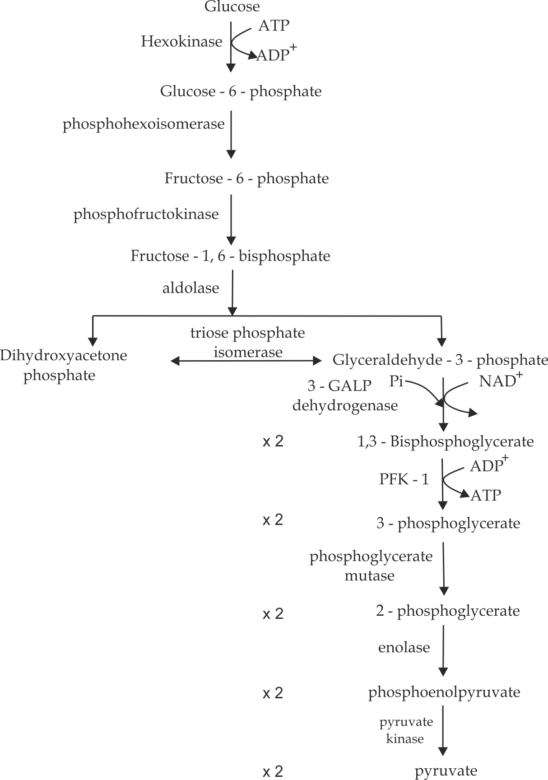

***Fig 3.2*** *the diagram showing the mechanism of glycolysis*

**The end products of glycolysis**

The total net yield of glycolytic pathway includes the following:

* 2 molecules of pyruvates.
* 2 molecules of ATP.
* 2molecules of NADH.
* Water molecules.

**Reasons for the phosphorylation of the glucose molecule:**

The aim of respiration is to produce energy in form of ATP, but the initial step of glycolysis involves the use of ATP due to the following reasons:

1. It prevents glucose molecules from diffusion out of the cell, because the charged glucose cannot easily cross the membrane.
2. It converts glucose molecule to more reactive form, this allow glycolysis to proceed.
3. It ensures that glucose is kept at a very low concentration inside the cell, so it will always diffuse down its concentration gradient from the blood into the cell.
4. It facilitates enzymes binding and specificity.
5. It also act as the starting material for the synthesis of pentose sugar and therefore nucleotides and glycogen.



**Sample question – 08**

**Style 1: Morogoro Mock 2020**

1. Suggest the reasons for the phosphorylation of glucose at the beginning of glycolysis.

**Style 2: Dar Mock 2021**

1. The initial stage of glycolysis involve the uses of ATP, Explain.
2. What would happen if the enzyme in glycolysis is irreversibly inhibited by a toxic substance?

**Hints:**

**Style 2 (b)**

If the enzyme is irreversibly inhibited, there would be no activation of the sugar and the glucose molecule would be less reactive hence, the process of glycolysis would cease.

**What is the advantage of respiring glycogen rather than glucose?**

Glycogen will provide more glucose molecules which will produce large number of ATP compared to one molecule of glucose which produces only 38 ATP; this explains why it is advantageous to respire on the glycogen rather than glucose especially during the strenuous exercise.



**Sample question – 09**

**Tahossa Kinondoni 2014**

* Why is advantageous to respire glycogen rather than glucose during strenuous exercise?



**Remember:**

The pyruvates produced during glycolysis; Have two possible fates, depending on the availability of oxygen in the cell. In the absence of oxygen (anaerobic condition) the pyruvate will undergo **fermentation**. Alternatively, In the presence of oxygen, the pyruvate will enter the **Krebs cycle** in which they will be completely oxidized into carbon dioxide and water.

1. **FERMENTATION**

**Fermentation** is a process whereby pyruvate from glycolysis is broken down to release lactate in animal muscles and alcohol (ethanol) and CO2 in plants and microorganisms such as yeast cells and bacteria.

It occurs in cytoplasm of a cell in the absence of oxygen gas. Hence, it is termed as anaerobic respiration. Fermentation is categorized into two types depending on the end products which include; **alcoholic** and **lactic acid** **fermentation**.

1. **Alcoholic fermentation**

It is a type of fermentation in which pyruvate from glycolysis is broken down to release alcohol (ethanol) and carbondioxide gas.

It usually occurs in higher plant cells and yeast cells under anaerobic conditions.

**The mechanism of alcoholic fermentation**

The mechanism of alcoholic fermentation involves **two (2)** processes,

**Firstly; Decarboxylation of pyruvate:**

Two molecules of Pyruvate from glycolysis undergo decarboxylation to release 2ethanal (acetaldehyde) and 2CO2 as a waste product under the presence of pyruvate decarboxylase enzyme.

Pyruvate decarboxylase

Pyruvate (3C) Ethanal (2C) + CO2

**Secondly; Reduction of Ethanal**

2ethanal is reduced by 2NADH2 from glycolysis to release 2ethanol under the presence of alcohol dehydrogenase enzyme.

Alcoholic dehydrogenase

Ethanal (2C) + NADH2 Ethanol (2C) + NAD+

**Importance of fermentation**

Alcoholic fermentation is important to living organisms due to the following reasons:

1. It is used in brewery industries, where ethanol is an important product for making beer, wine and other brewery products.
2. It is used in backery industries whereby CO2 produced makes rising to breads (doughing).
3. It is used as the source of fuel such as ethanol fuel.



**Sample question – 10**

**Necta 2014**

* In what ways are fermentation processes useful to human being?

1. **Lactic acid fermentation**

It is a type of fermentation in which pyruvate from glycolysis is broken down to release lactate. It usually occurs in vertebrate muscles during strenuous activities.

**The mechanism of lactic acid fermentation**

The mechanism of lactic acid fermentation involves only **one (1)** step, in which pyruvate from the glycolysis is reduced by NADH2 into lactate under the presence of lactate dehydrogenase enzyme.

Lactate dehydrogenase

Pyruvate (3C) + NADH2 Lactate (3C) + NAD+

**Sample question – 11**

**Dar Mock – 2015**

* In the process of glycolysis, the formation of pyruvate involves the following reactions:

NAD + + 2H+  NADH + H+

Explain what would happen if:

1. An animal cell respiring anaerobically.
2. A yeast cell respiring anaerobically.



***Fig 3.3:*** *Oxygen gas is much required in strenuous exercises to avoid muscle fatigue*

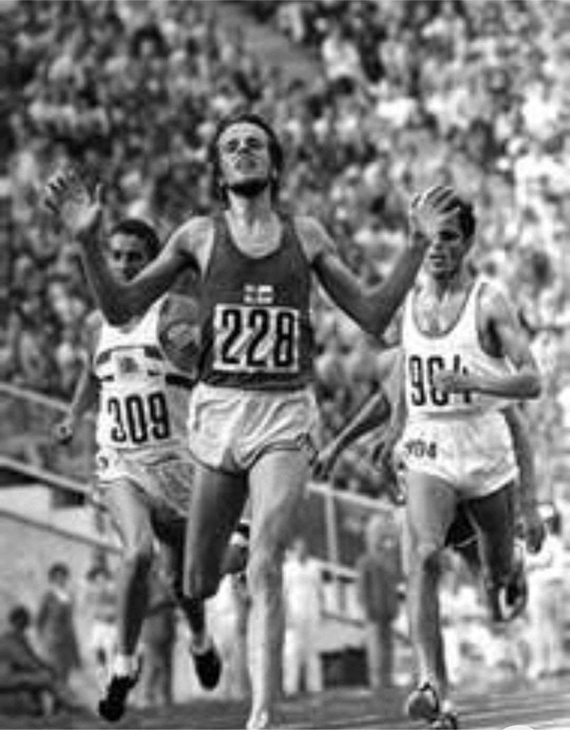

**Strenuous exercises and muscle fatigue**

During sprinting (100 metres sprint) such as when you run for a bus, the initial 30 seconds of the sprint, the sprinter uses direct ATP stores in the muscles or indirect ATP from creatine phosphate also stored in the muscles, When these are exhausted, the energy is obtained through the respiration, and if the energy requirements exceeds the rate at which oxygen is supplied to the muscles due to high metabolic demand in the muscles due to intensity muscle contraction , the muscles then generate energy through anaerobic respiration which produces less amount of ATP energy and lactic acid as by – product. The accumulation of lactic acid may result into **muscle fatigue**

For long periods of exercise such as marathon running, muscle cells need oxygen supplied by the blood for aerobic respiration. This provide far more energy (38 molecules of ATP from each molecule of glucose), but the rate at which it can be produced is limited by how quickly oxygen can be provided which is also depending on the heart rate and breathing rate unless otherwise my result into anaerobic respiration, this explains why you can’t run a marathon at the same speed as a sprint.

**How is the muscle fatigue paid?**

After a sprint race is over, the lactate in the athlete’s muscles is carried in the blood to the liver. Here the lactate is oxidized to carbondioxide and water, releasing energy that enables further ATP production. The oxygen required to do this is called the **oxygen debt.** This explains why the level of lactic acid is continues to rise at the end of race and also explain why is the athletes oxygen consumption is still higher than normal sometimes after the race.

***Bonus conceptual questions:***

**Sample question – 12**

**Be carefully with these two famous questions:**

**Tahossa 2014**

1. Why the amount of lactic acid in the blood increases at the end of the race although oxygen consumption rises during the race?
2. Why is the athlete’s oxygen consumption still higher than normal sometimes after the race?

Hints:

1. Oxygen consumption rises in order to perform aerobic respiration although is not enough to meet the metabolic demand so anaerobic continues and lactic acid produced, as the result at the end of the race, still large quantity of lactic acids are carried through the blood from the muscles to the liver to be converted into pyruvate again.
2. The oxygen consumption is still higher sometimes after the race in order to repay the oxygen debt, i.e. large volume of oxygen is supplied to the liver in order to convert lactic acid into pyruvate again.



**Similarities between alcoholic and lactic acid fermentation**

1. Both occur in the absence of oxygen gas.
2. Both produce energy in the form of ATP.
3. Both involve the use of enzymes.
4. Both involve glycolytic pathway.
5. Both take place in the cytoplasm.

**Table 3.4 Differences between alcoholic and lactic acid fermentation:**

|  |  |
| --- | --- |
| **Alcoholic fermentation** | **Lactic acid fermentation** |
| Alcohol is produced. | Lactate is produced. |
| Carbondioxide is liberated. | Carbondioxide is not liberated. |
| It produces 210 kJ of energy. | Liberates 150kJ of energy. |
| Energy locked in ethanol cannot be available in later stage. | Energy locked in lactate is available in the later stage. |



**Sample question – 13**

**Mzumbe gauging 2009**

Study the photography below carefully:

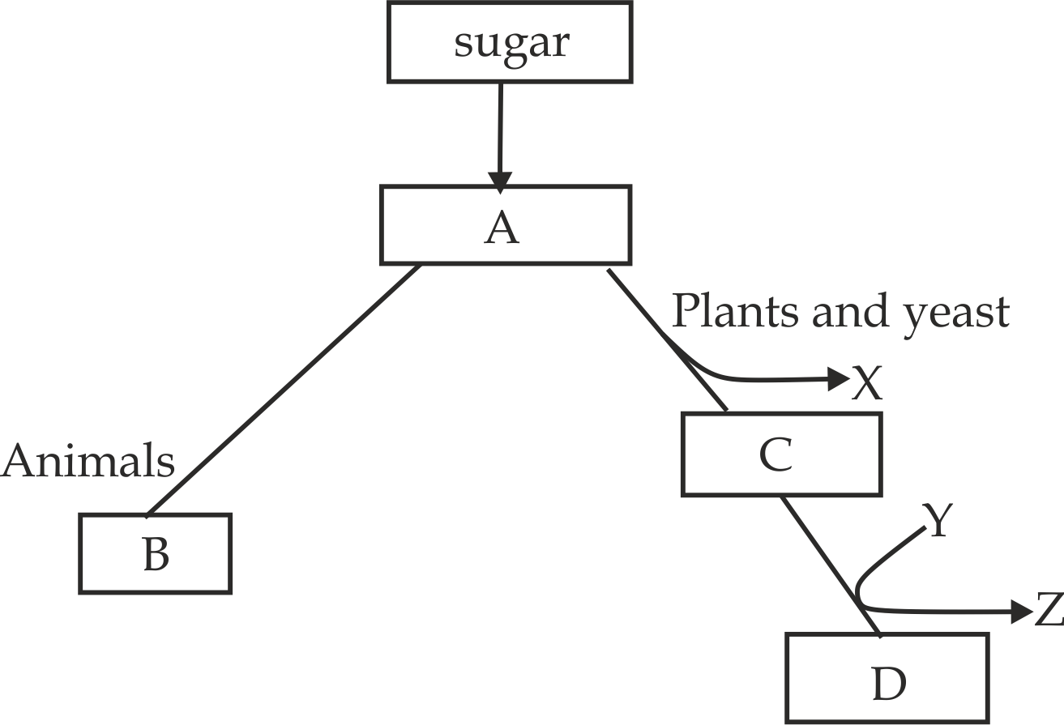

1. Name the substance **A, B, C, D, X, Y** and **Z**.
2. Compare alcoholic fermentation by yeast cells with lactic acid fermentation in a vertebrate muscle cell during a vigorous exercise.

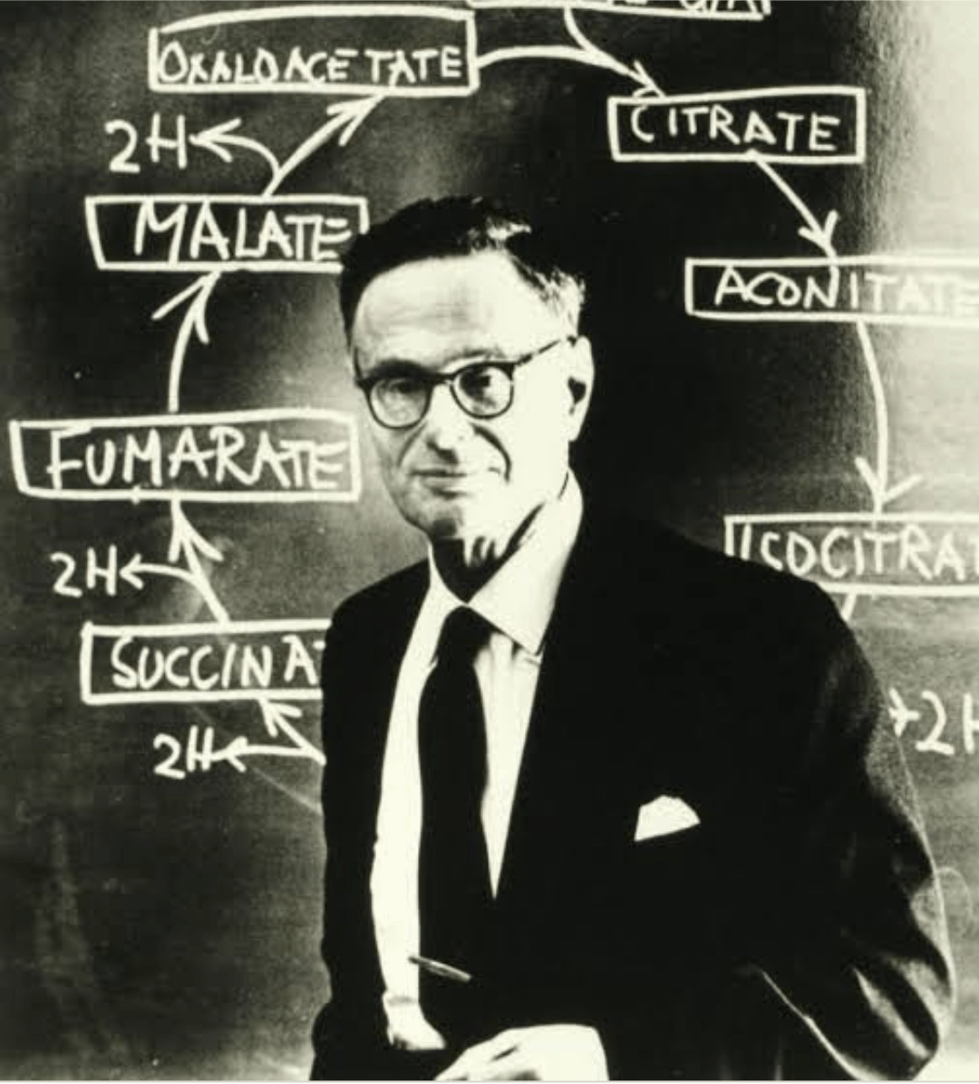

***Fig 3.4****: Hans Rudolf Krebs worked out the details of the cycle in 1930.*

1. **Krebs cycle**

**Krebs cycle** is literally named after Sir **Hans Adolf Krebs** (1900 – 1981) *Fig 3* *.4*; worked out the details of the cycle in 1930. **Krebs cycle** is the process in which pyruvate from glycolysis is oxidized to release a pair of hydrogen atoms, carbondioxide and ATP. The Krebs cycle takes place in the matrix of the mitochondrion.

It is also known as tricarboxylic acid cycle **(TCA)** because it involves in the formation of compound which possess three carboxyl group called citric acidor **Citric acid cycle** because it involves in the formation of the first compound called citric acid (citrate).

**Importance of Krebs cycle**

The Krebs cycle (TCA) is an important metabolic pathway to living organism due to the following reasons:

1. It brings about degradation of the macromolecule such as pyruvate into micromolecule such as CO2 gas.
2. It produces reducing powers such as NADH and FADH for the electron transport chain.
3. It acts as interconvertional centre for other respiratory substrate such as lipids and proteins.
4. It produces carbondioxide gas to the atmosphere which is necessary for photosynthesis.
5. It leads to the production of intermediate compound which are essential to the manufacture of other chemical substances such as lipids, amino acids and carotenoids.

**Sample question – 14**

**Tahossa 2022**

1. Why Krebs cycle is sometimes called:
2. Citric acid cycle
3. Tricarboxylic acid cycle (TCA)
4. In which two main ways is Krebs cycle important in respiration?



**What are the stages of Krebs cycle?**

**Krebs cycle** is divided into a sequence of **nine (9)** enzymes – catalysed reactions and each step is facilitated by a specific enzyme. . The mnemonics for those **10 steps** is given by the ideas of the song:



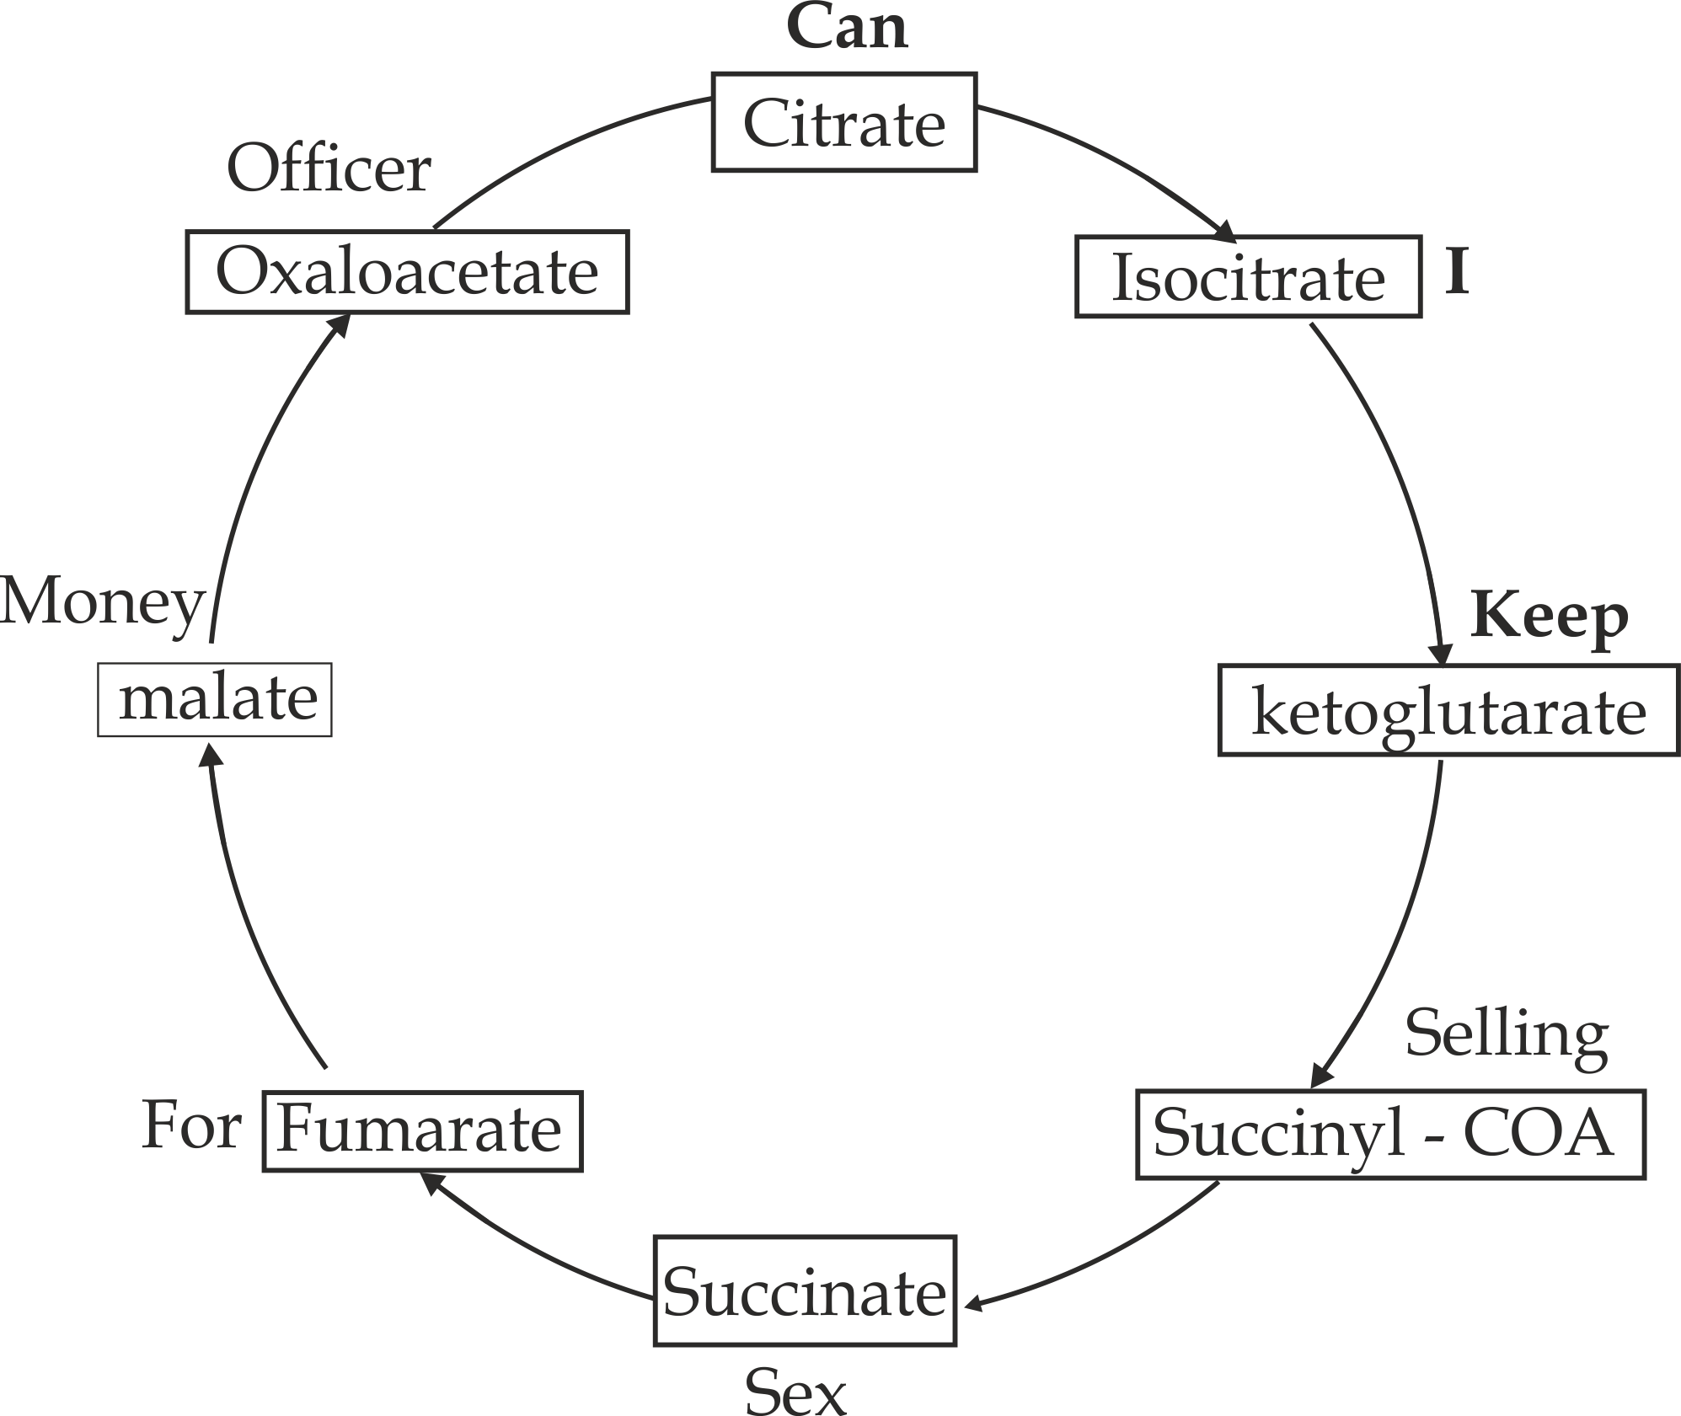

**Step 1:**  **Transition stage**

Before entering the actual Krebs cycle, pyruvate (3C) molecules inside the matrix of mitochondrion are converted to a two – carbon compounds called **Acetyl**. This step is between glycolysis and Krebs cycle; it is referred to as the ″**link reaction**” or ″ **grooming stage**”.

During this process a molecule of pyruvate formed from the glycolysis is oxidatively decarboxylated into CO2, (acetyl) and a pair of hydrogen atoms which reduce NAD2+ into NADH2.

Acetyl reacts with the sulfhydryl group of coenzyme A (COA –SH) to form acetyl – coenzyme A (acetyl-coA) which is then transferred to the Krebs cycler for further releasing of energy.

**Consider a word equation below:**

Pyruvate dehydrogenase

2Pyruvate + 2NAD+ 2Acetyl + 2NADH2 + 2CO2

Pyruvate decarboxylase

2Acety + Coenzyme A 2Acetyl – COA

**Step 2: Synthesis of citrate**

Acetyl –COA (2c) combines with oxaloacetate (4c) to form citrate (6c) under the presence of citrate synthetase.

Citrate synthetase

Acetyl (2c) + oxaloacetate (4c) Citrate (6c)

**Step 3: Isomerization of citrate**

Citrate (6c) is rearranged to its isomer called isocitrate under the presence of aconatase enzyme. This process involves dehydration followed by hydration.

Aconatase

2(citrate) 2 (Cis – aconatase) +H2O

(6c) (6c)

Aconatase

2(Cis – aconatase) + H2O 2 (Isocitrate)

**Step 4: Oxidatively decarboxylation of isocitrate**

Isocitrate is oxidatively decarboxylated into  – ketoglutarate, CO2 and NADH2. This reaction is catalysed by isocitrate dehydrogenase and oxalosuccinate decarboxylase.

Isocitrate dehydrogenase

2 (Isocitrate) + 2NAD+  2(oxalosuccinate) + NADH2

Oxalosuccinate decarboxylase

2(oxalosuccinate) 2( – ketoglutarate) + 2C02

**Step 5: Oxidatively decarboxylation of  – ketoglutarate**

 – ketoglutarate is oxidatively decarboxylated to succinyl – COA, C02 and NADH2. This reaction is catalysed by  – ketoglutarate dehydrogenase and  – ketoglutarate decarboxylated. COA serves as carrier of the succinyl group.

 – keto dehydrogenase

2( – ketoglutarate) + 2NAD+ 2SuccinylCOA + 2NADH2 +CO2

2 COASH 2SH

**Step 6: Conversion of succinyl COA to succinate**

Succinyl COA is converted into succinate by losing the COA group under the presence of succinyl COA synthetase, this reaction releasing energy enough to make ATP.

Succinyl COA synthetase

2 (succinyl COA) + Pi 2(succinate) + ATP

COASH

**Step 7: Oxidation of succinate to fumarate**

Succinate is oxidized to fumarate by the presence of succinate dehydrogenase enzyme. In this reaction FAD+2 is reduced to FADH2.

Succinate dehydrogenase

2(Succinate) 2FAD+2 2(Fumarate) + FADH2

**Step 8: Hydration of fumarate to malate**

Fumarate is hydrated to malate. This reversible reaction is catalysed by fumarase, which is also known as fumarase hydrates.

Fumarase

2(Fumarate) +H20 2(malate)

**Step 9: Oxidation of malate to oxaloacetate**

This is the last reaction of the Krebs cycle in which malate is oxidized into oxaloacetate and NADH2 under the presence of malate dehydrogenase enzyme.

Malate dehydrogenase

2(malate) + 2NAD+  2(oxaloacetate) + 2NADH2

**Summary of the essential features of Krebs cycle**

1. Acetyl group (2c) enters the cycle by combining with a 4 carbon compound called oxaloacetate to produce a 6 carbon compound citrate.
2. Citrate is oxidized in many enzymatic – catalyzed reactions to produce CO2 and energy in form of ATP, FAD+2 and NAD+2, finally oxaloacetate will be formed and the reaction alternate once again.

**Illustration of Krebs cycle**

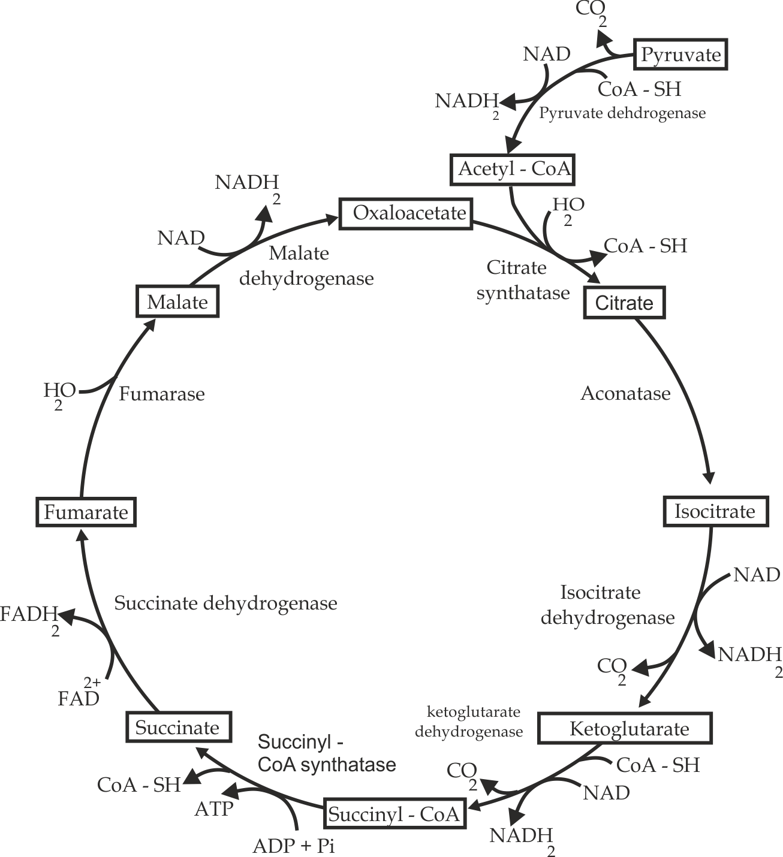

***Fig 3.5*** *Mechanism of Krebs cycle*



**Did you know?**

**Rat poison inhibits aconatase enzyme which prevents the tricarboxylic acid cycle to proceed forward result into respiratory failure, hence death.**

**End products of Krebs cycle**

The total net yield of glycolytic pathway includes the following products**:**

* 2 molecules of ATP.
* 6 molecules of NADH2.
* 2 molecules of FADH2.



* Carbondioxide

**Sample question – 15**

**Style 1: St. Annie Marie 2017**

* With the aid of a diagram, describe the events which takes place in Tri – carboxylic acid cycle.(10 marks)

**Style 2: Jecas 2005**

* The release of energy from a glucose molecule occurs in three (3) stages namely; glycolysis, Krebs cycle and electron transfer; Give the summary of the essential features of two (2) of these stages.

**Style 3: Jecas 2015**

* The product of glycolysis process which will be needed in the Krebs cycle is pyruvate. Does the pyruvate enters the Krebs cycle directly? Explain your answer.

**Style 4: Mtwara and Lindi Mock 2021**

* Illustrate the steps involved in the Krebs cycle.

**Table 3.5 differences between glycolysis and Krebs cycle**

|  |  |
| --- | --- |
| **Glycolysis** | **Krebs cycle** |
| It is a first stage in respiration. | It is a second stage in respiration. |
| It occurs in the cytoplasm. | It occurs in the mitochondrion. |
| The substrate is glucose. | iii. The substrate is Acetyl – CoA. |
| The products are energy and pyruvate. | The products are energy, C02 and H2O. |
| It consumes ATP for initial phosphorylation. | It does not consume ATP energy. |
| vi. It occurs in aerobic and anaerobic respiration. | vi. It occurs in aerobic respiration only. |

1. **Electron transport chain (ETC)**

**Electron transport chain** is a process whereby energy in form of hydrogen atoms produced during glycolysis and Krebs cycle are oxidized to release direct ATP,It occurs in the mitochondrion membrane called **cristae**, which is folded to increase surface area to volume ratio for metabolic reactions.

**Importance of electron transport chain**

1. It ensures completely oxidation of glucose.
2. It produces metabolic water which is available for various physiological processes.
3. It provides direct ATP that is readily available for the living cells.

**What is the respiratory chain?**

Respiratory chain is a series of hydrogen carries in the electron transport chain. These carriers are embedded in the inner membrane of the mitochondrion. Basically there are four (4) types of electron carriers in the respiratory chain which includes; NAD, FAD, coenzyme Q and cytochromes.

**Mechanism of electron transport chain**

* The hydrogen atoms carried by reduced NAD+2 and FAD+2 are transferred to a series of carriers including NAD+2, FAD+2, Coenzyme Q and Cytochrome at progressively lower energy level.
* As hydrogen passes from one carrier to the next, the energy released is used to combine ADP+ and inorganic phosphate (Pi) to form ATP.
* The hydrogen atoms carried by NAD+2 are shunted into the chain at carrier one, NAD+2 (a step ahead FAD+2) and produces a total of 3ATP molecules as they pass through the carriers. Meanwhile the hydrogen atoms carried by FAD+2 are introduced in the chain at carrier two, FAD+2. Therefore, a pair of hydrogen atoms carried by FAD+2 makes a total of 2ATP molecules as it passes through the carriers.
* However, after the FAD+2 stage, hydrogen atoms split into protons (H) and electron (e) and takes another route out of the chain as the electron pass through the **cytochrome system ,**Accordingly, the pathway can be called the **electron transport chain**.
* Finally, protons and electrons recombine to form hydrogen atoms which combine with oxygen gas to form water; this reaction is catalyzed by the cytochrome oxidase enzyme. The formation of ATP through the oxidation of hydrogen atoms is normally called **oxidative** **phosphorylation.**
* **Cyanide and carbon monoxide** are the major inhibitors of cytochrome oxidase enzyme which catalyses the reaction between hydrogen and oxygen to complete the formation of ATP and water at the end of the respiratory chain. The inhibition of cytochrome oxidase prevents the removal of hydrogen atoms which accumulate in the cell and aerobic respiration cease,the organism may die due to depletion of energy and high level of acidity in the cells.

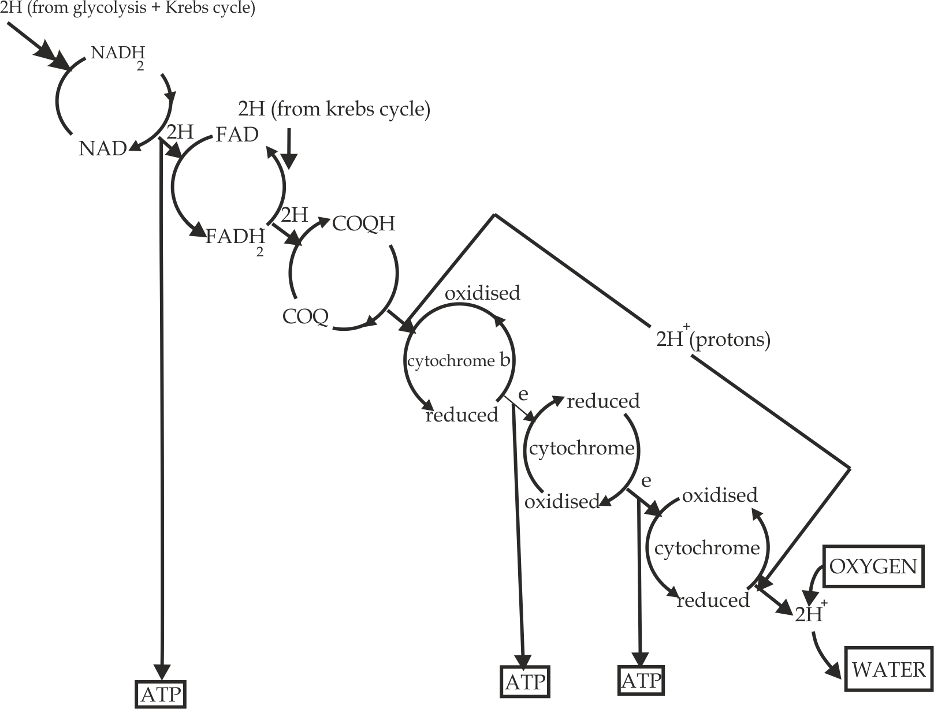

***Figure 3.6*** *Illustration of electron transport chain*

**Sample question – 16**

**Canossa high school 2019**

1. Name the molecule that conserve most of the energy from the citric acid redox reaction.
2. How is this energy converted to form that can be used to make ATP?

**Hints:**

1. NADH2
2. Explain the mechanism of electron transport chain.



**Table3.6 Differences between aerobic and anaerobic respiration**.

|  |  |
| --- | --- |
| **Aerobic respiration** | **Anaerobic respiration** |
| It occurs in the presence of oxygen | It occurs in the absence of oxygen |
| It produces large amount of energy. | It produces small amount of energy. |
| End products are water and CO2 | End products are alcohol (ethanol) and CO2 in plants and lactic acid in animals. |
| Final electron acceptor is oxygen. | Final electron acceptor is pyruvate. |
| It occurs in the cytoplasm and mitochondrion. | It occurs in the cytoplasm only. |

**Table 3.7 Differences between respiration and photosynthesis:**

|  |  |
| --- | --- |
| **Respiration** | **Photosynthesis** |
| Oxygen is used up | Oxygen is released |
| Carbondioxide is released | Carbondioxide is used up |
| It occurs in mitochondria | It occurs in chloroplast |
| It is catabolic process | It is anabolic process |
| Energy is incorporated into ATP | Energy is stored in carbohydrate |

**3.3 ATP SUMMATION**

**ATP summation** is the total number of ATP molecules produced after the respiration of a glucose molecule. The number of ATP molecules produced normally depends on the sort of metabolism; which is either aerobic or anaerobic respiration.

1. **In aerobic respiration:**

When glucose molecule is completely oxidized aerobically 38ATP molecules are produced; 40 molecules of ATP are actually formed but 2ATP is initially used in the activation of sugar as the result the net yield is 38 ATP.

**Table 3.8 Amount of ATP produced from glucose respired aerobically:**

|  |  |  |  |  |
| --- | --- | --- | --- | --- |
| **Respiratory process** | **Number of NADH**  **( x 3ATP)** | **Number of FADH (x2ATP)** | **ATP direct formed** | **Total number of ATP** |
| **Glycolysis:** | 2 | - | 2 | 8 |
| **Link reaction** | 2 | - | - | 6 |
| **The Krebs (TCA) cycle** | 6 | 2 | 2 | 24 |
| **Total count** | **10** | **2** | **4** | **38** |



**Sample question – 17**

**Loyola High school 2009**

* Compute the total yield of ATP when one molecule of glucose is fully oxidized during respiration.

1. **In Anaerobic respiration**

When glucose is anaerobically respired produce only 2ATP, this is because anaerobic pathways do not complete the entire high energy bond in glucose due to the fact that most of the energy is still held by these bonds.

**Sample question – 18**

**Tahossa 2014**

* For every molecule of glucose, 38 ATP molecules are produced during aerobic respiration, but only 2 molecules of ATP are produced during anaerobic respiration, why?



**3.4 EFFICIENCY OF ENERGY TRANSFER**

Efficiency of energy transferis the measure of the percentage or proportional of energy released during respiration that is converted into direct ATP.

1. **Efficiency of energy transfer in aerobic respiration**

During aerobic respiration, 38 ATP molecules are normally produced for each molecule of glucose that is oxidized.

C6H1206 + 602  C02 + H20 + 38 ATP

Energy contained in one ATP is 30.6 KJ/mole

Total ATP energy = 38 ATP x 30.6 KJ/ mole = 1162.8 KJ/ mole

Efficiency of energy transfer: Total ATP energy x 100%

Total energy released

Whereby the total energy released by complete oxidation of glucose is 2880KJ/mole.

Efficiency of energy transfer = 1162.8 KJ/ mole x 100%

2880 KJ/ mole

40.4%

Therefore; the efficiency of energy transfer in aerobic respiration is 40.4%

1. **Efficiency of energy transfer in anaerobic respiration**

During alcoholic fermentation, 2 ATP molecules are normally produced for each molecule of glucose that is used.

Glucose 2 Ethanol + 2CO2 + 2ATP

Energy contained in one ATP is 30.6 KJ/mole, thus energy contained in 2ATP is 2 x 30.6KJ/mole which is equal to 61.2KJ/mole. Conversion of glucose to ethanol produces 210KJ/ mole. The efficiency of energy transfer during alcoholic fermentation is 61.2/ 210 x 100% = **29.1%.**

Alternatively, in lactate fermentation, 2 ATP molecules are produced for every molecule of glucose used.

Glucose 2 lactate +2 ATP

The amount of energy contained in 2ATP molecules is 2 x 30.6 = 61.2 KJ. The total energy released during the conversion of glucose to lactate is 150 KJ/ mole. Thus, the efficiency of energy transfer during lactate fermentation is 61.2 /150 x 100% = **40.8%.**



**Sample question – 19**

**Style 1: Necta 2005**

1. What is respiratory quotient (RQ)?
2. If oxidation of one molecule of glucose yields about 2830 KJ and one molecule is equivalent to 33 KJ/ mole. What will the efficiency of glycolytic pathway and Krebs cycle be for the extraction of energy in one molecule of glucose?



**Style 2: Jecas 2011**

1. Make a list of six (6) similarities (including biochemical ones) between photosynthesis and aerobic respiration.
2. During alcohol fermentation, a total of 210KJ /mole is released when glucose is converted into ethanol.

Glucose 2ethanol + 2CO2 + 2ATP

Calculate the efficiency of transfer of energy in the process, if a single ATP molecule contains 30.6 KJ/ mole.

**3.5 RESPIRATION OF ALTERNATIVE RESPIRATORY SUBSTRATES**

Both fats and proteins can be used as alternative respiratory substrates in respiration when all carbohydrates are exhausted. The pathways by which these respiratory substrates are used into respiration.

**A. Lipids**

Fats or oils are first hydrolysed by lipase digestive enzyme to glycerol and fatty acids.

Lipase

Lipid glycerol + fatty acids

1. **Glycerol** is phosphorylated by ATP into glycerol 3 – phosphate, then dehydrogenated with NAD into glyceraldehyde 3 – phosphate (3 – PGAL); 3 – PGAL enters the glycolytic pathway with subsequently releasing of ATP energy.
2. **Fatty acids** contain a long hydrocarbon chain. This is oxidized by successive removal of two – carbon fragments, in the form of acetyl coenzyme A. This process known as **β – oxidation,** occurs in the matrix of the mitochondrion. The acetyl coenzyme A is then oxidized to carbondioxide and water by the Krebs cycle and electron transport pathway, and the coenzyme A is available for re – use.

**What are the advantages of oxidizing fat as a respiratory substrate?**

The oxidation of fat has advantage of producing large number of hydrogen atoms; these can be transported by hydrogen carriers down the electron transport system to produce large number of ATP. Exactly how many ATP molecules are produced by the complete oxidation of a fatty acid depends on the number of carbon atoms it contains. A fatty acid with a very long hydrocarbon chain will obviously give more molecules of acetyl COA and therefore more ATP molecules, than one with a relatively short chain. The complete oxidation of a molecule of stearic acid with 16 carbon atoms in hydrocarbon chain yield a net total of about 150 molecules of ATP.The is nearly four times as many as are given by the oxidation of a single glucose molecule.

1. **Proteins**

Protein is the last option source of energy in the bodies of most animals. It is only utilized for energy during case of extreme starvation that is, when both carbohydrates and lipids are completely exhausted or sometimes it occurs when the amino acids are in excess in the body. The protein is first hydrolysed into its constituent’s amino acids. Each amino acid is then **deaminated.** Its amino (NH2) group is removed from amino acid as **ammonia**. The ammonia is quickly converted into **urea** which is later excreted as **urine.**

Meanwhile, the remaining group enters the respiratory pathway depending on the number of carbon atoms it contains with subsequently release of energy. For examples:

1. The portions with 3 carbon atoms such as ″aspartate” are converted into pyruvate.
2. The portions with 4 carbon atoms such as ″ alanine” are converted into oxaloacetate.
3. The portions with 5 carbon atoms such as ″glutamate” are converted into  – ketoglutarate.
4. The portions with 6 carbon atoms also enter the citrate or isocitrate with subsequently energy releasing.



**Sample question – 20**

**Dar Mock 2018**

1. i. What do you understand by the term RQ?

ii. What causes the variation of RQ?

1. Explain briefly advantage of oxidizing lipid as respiratory substrate.
2. Outline the respiratory pathway using lipid and protein substrates.
3. Explain the factors affecting basal metabolic rate (BMR) in human.

**Summary of the respiratory break down of carbohydrates, fats and proteins**

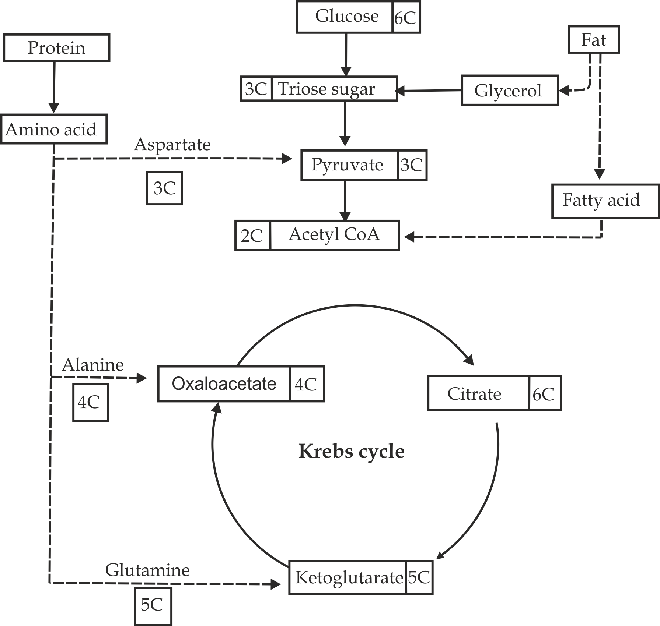

***Figure 3.7*** *Respiratory pathways of carbohydrates, fats and proteins*

**3.6 RESPIRATORY QUOTIENT (RQ)**

The **respiratory quotient** is the ratio of the volume of carbondioxide evolved to volume of oxygen consumed by an organism in a given period of time.

*Per unit time*

R.Q = Volume of CO2 evolved

Volume of O2 consumed

**Significances of RQ**

1. It helps to indicate the type of the respiratory substrate which is being oxidized.e.g; this could either be glucose, lipid or protein.

**Case 1;** the RQ is expected to be equal to 1 when a carbohydrate such as glucose is being oxidized.

**For glucose**:

C6H12O6 +6O2 6CO2 +6H2O

RQ = CO2 evolved = 6 = 1

O2 consumed 6

**Hence RQ = 1** (When glucose is being oxidized)

**Case 2;** the RQ is expected to be less than 1 when a fat (or oil) is being oxidized.

**For stearic acid:**   
C18H36O2 + 26O2 18CO2 + 18H2O

RQ = CO2 evolved = 18 = 0.7

O2 consumed 26

**Hence RQ = 0.7** (When lipid is being oxidized)

**Case3;** the RQ is expected to be less than 1 when protein also is being oxidized.

**For protein:**

**The average RQ is 0.9**, as protein is normally not used to great extent, RQ of slightly less than 1.0 can be taken to mean fat is oxidized.

1. **It indicates the sort of metabolism.**

The RQ is expected to be greater than 1 in anaerobic respiration, with the result that the amount of carbondioxide produced exceeds the amount of oxygen used.

**For anaerobic respiration:**

C6H12O6 2C2H5OH + 2CO2

RQ = CO2 evolved = 2 = ∞

O2 consumed 0

**Hence RQ> 1** (Anaerobic respiration)

**Note:**

Under normal conditions the human RQ is in the range of **0.8 – 1.0,** indicating that mixture of the respiratory substrates are respired. Thus the RQ value is not conclusive evidence of which respiratory substrate is being catabolized.



***Did* you know?**

***Brain is the only organ whose tissues catabolized glucose only; in this case the RQ is always expected to be 1.***

**Sample question – 21**

**Style 1: Dar Mock 2020**

* Why is the RQ for human range between 0.8 and 1.0?

**Style 2: Jecas 2015**

1. Define the term respiratory Quotient (RQ).
2. State the importance of RQ in living things
3. By using example (chemical equations), briefly explain how you would expect the RQ value to be less than 1, equal to 1 and greater than 1.

**Style 3: Loyola High school 2009**

1. The equation for respiration of the fat tripalmitin is:

2C51H98O6 + 145O2 102CO2 + 98H2O

What is the RQ for tripalmitin?

1. What is the RQ when glucose is respired anaerobically to ethanol and CO2?

**Style 2: Kilimanjaro Mock 2020**

1. Read the equation below then answer the questions that follows:

C6H12O6 2 C2H5OH + 2CO2 + energy

1. Find the respiratory quotient of the above equation.
2. Explain the importance of RQ.



**3.7. BASAL METABOLIC RATE**

The **basal metabolic rate** of an organism is the minimum rate of energy required just to stay alive during rest or sleep. It is actually the amount of energy needed to maintain the body’s constant internal environment at rest and doing nothing for basic functions such as breathing, beating of the heart, and keeping up the body temperature and so on – in short maintain life of the cells. This is the minimum amount of energy on which the body can survive. The rate of metabolism *(BMR)* can be estimated by measuring the heat energy produced in a given time, in a **special calorimeter room.**

**What are the conditions for determining BMR?**

In human BMR is measured under the following necessary conditions:

1. It required a standardized rest time of between 12 to 18 hours of physical and mental relaxation.
2. No meal is taken during that period to avoid the effect of digestion and absorption.
3. It should be normal conditions of the environment temperature (20 - 25℃) and pressure to maintain respiration, circulations and functions of the visceral organs such as heart, liver and brain.

**Factors which affect BMR**

The following factors influence the variation of basal metabolic rate among individuals: The same factors affecting the rate of respiration;

1. **Age**

The BMR decreases with age (aging). Children have higher BMR than adults. A decrease in lean muscle mass during adulthood may results in a slow steady decline of roughly 3% per year in BMR after the age of about 30.

1. **Sex**

The BMR of females is lower than that of males. In average the BMR of females is 5 to 10 percentage lower than that of males. This is because; Men naturally have more muscle mass for metabolism and less fat than females regardless of the age. For a healthy young woman it is about 150 K+Jm-2h-1, and for a healthy man it is about 167 KJm-2h-1.

1. **Physical activity**

The BMR of people involved in heavy activities is higher because they need more oxygen for metabolism such as respiration.

**Table 3.9 Energy expenditure in relation to different kinds of activity***.*

|  |  |  |
| --- | --- | --- |
| **Energy expenditure / kjm-1** | | |
|  | **Woman** | **man** |
| **Sleeping** | 3.8 | 4.2 |
| **Sitting** | 5.0 | 5.8 |
| **Light work** | 15 | 17 |
| **Maximum work** | 57 | 63 |

1. **Body size**

Small organisms have large surface area to volume ratio for metabolism, hence large BMR than large organisms.

1. **Body composition**

A fat tissue has a lower metabolic activity than muscle tissue. As lean muscle increases, the metabolism rate increases.

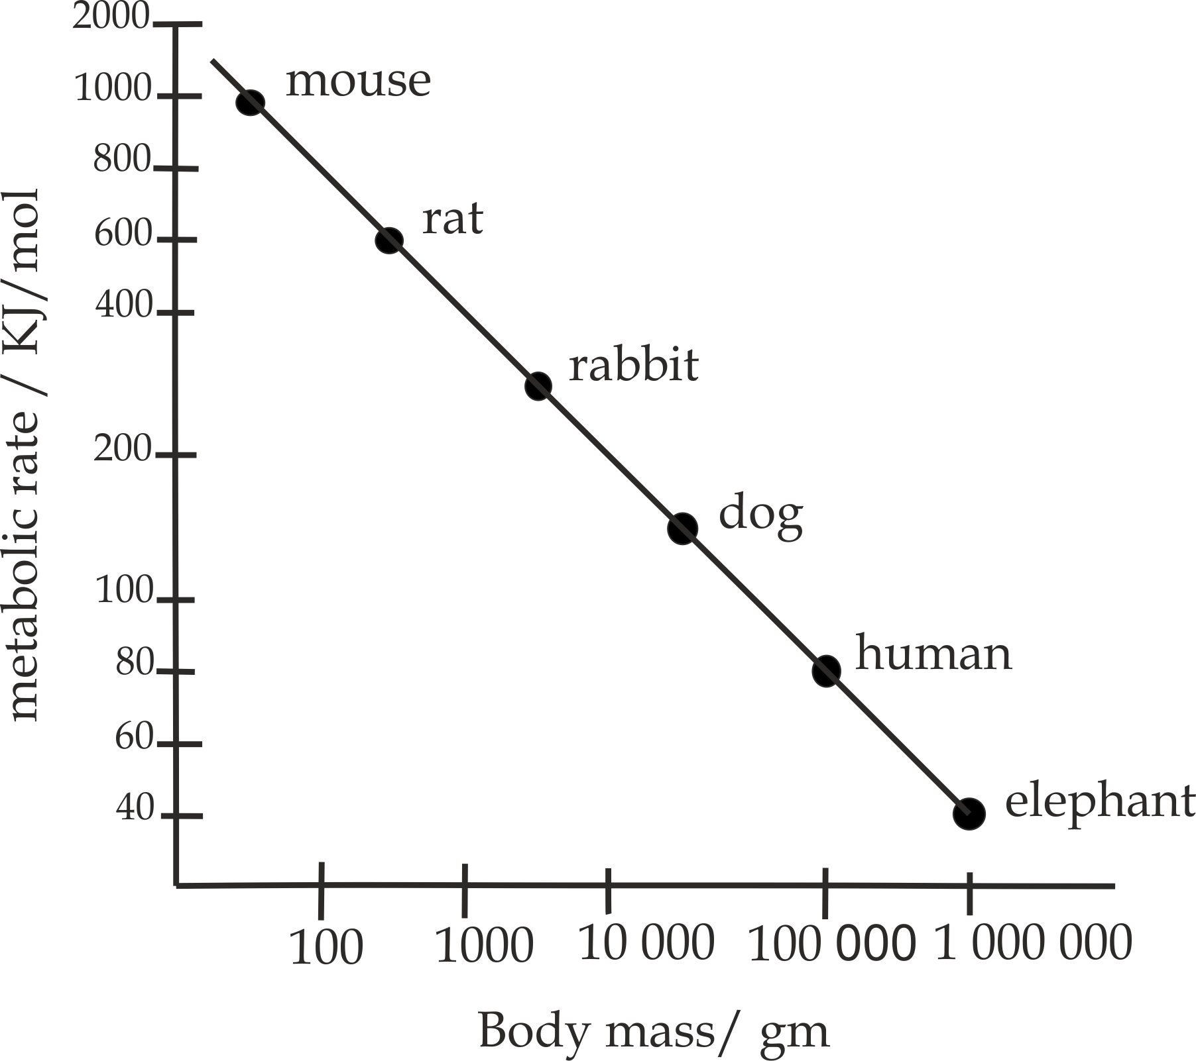

***Figure 3.10*** *the relationship between body mass and basal metabolic rate*

1. **Body temperature**

The BMR of people in tropical climate is generally up to 20 percent higher than in people living in cold climate in order to maintain constant body temperature.

1. **Healthy status**

Fever, illness or injury may increase resting metabolic rate to 2 folds. Therefore, a sick person has higher rate of metabolism than a healthy person.



**Sample question – 22**

**Style 1: Morogoro Mock 2020**

Briefly explains how the weather, body size, body composition, sex and age influence the variation of basal metabolic rates among individuals.